

HOW TO IMPROVE ACCESS PERFORMANCE

Compact your database often to reclaim space
Compacting your database reclaims unused space and makes almost all operations faster. You should do this on a regular basis. Also, be sure to compact anytime you import or delete objects in your database, or compile and save VBA code.
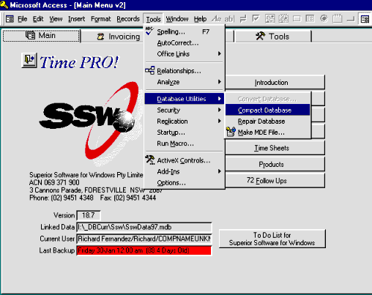

Increase RAM
Increase the amount of RAM on your computer. The minimum acceptable amount of RAM for Access 97 is 16 MB. 32 MB is preferable. Windows NT requires more RAM than Windows 95 to achieve the same level of performance, so if you have the choice always get 64 MB of RAM.

Keep Enough Local Hard Disk Space Free
Access requires a fair amount of disk space to operate, especially with large databases. Operations such as running large action queries, adding lots of data, importing data, and compiling and saving module code can use a lot of additional space on a temporary basis. Additionally, transactions and compacting the database can use a lot of disk space. A good rule of thumb is to have roughly 5-10 times the size of your largest database available in free local storage. We always say you should have at least 100 MB free.

Run on a Computer with a Pentium processor
Access requires a Pentium processor for adequate performance. Typically, a 100 MHZ processor is the minimum.

Avoid Wallpaper
Avoid wallpaper, unless you are using a small, tiled bitmap.

Close Access Occasionally to Reclaim Leaked Memory
Almost all Windows applications "leak" memory. This is due to data structures, variables and other memory consumers that are not correctly released by applications. By closing Access, you allow Windows to reclaim this leaked memory.

Close Unneeded Applications
Free up memory by closing applications that you aren't using. If you are using the System Agent from the Microsoft Windows Plus Pack, consider turning it off to make more memory available for your Access application.

Disable Office Startup Programs
Office installs one or more startup programs in your Windows\Start\Menu\Programs\Startup folder. Typically, the two programs installed are the Office Fast Start and Office Find Fast indexing utilities. Consider removing these items from the Startup folder, as they use up memory. Additionally, the Find Fast indexer runs continuously, and can dramatically reduce Access application performance.

Don't Use Disk Compression Software
Do not use disk compression software on the drive where you have installed Microsoft Access, or where your database file(s) are located. Disk compression exacts a heavy toll on performance, and this toll can be acute in database applications.

Don't Use RAM Disks
Don't waste RAM by using a RAM disk. RAM disks are a vestige of 16-bit Windows and DOS systems, and have no place on modern computers.

Install Access Locally
Do not install Microsoft Access, or its related Microsoft Office components on a network drive. Most applications, including Access and Office perform better when run from local drives.

Install Windows Locally
The Windows operating system should be installed on a local fixed drive on your computer. Because of the number of components involved in running Windows, a network installation of Windows causes poor performance, especially for database applications.

Keep Databases Local
Whenever possible, keep your databases local instead of on a network drive. In almost all cases, local disk access is faster than network access.

Adjust Virtual Memory Settings
Although Windows 95's default virtual memory settings are adequate for most systems, you may want to consider lowering the settings if you don't have a lot of space on the disk being used for virtual memory, or you may wish to use another local drive that is faster than the one being used by default for virtual memory.

Open Databases Exclusively
If you are opening a database, and no other users need to use the database, open the database in exclusive mode. To do this, check the Exclusive checkbox in the Open Database dialog, as shown below.
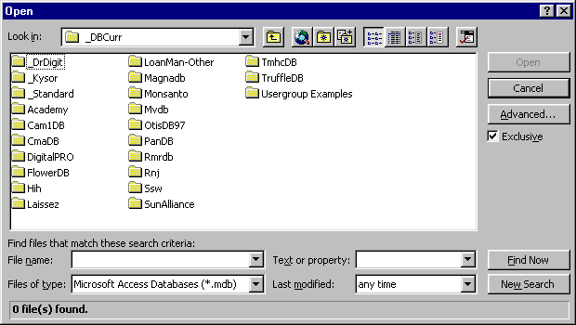

Optimise your Disk
Keep your hard disk in optimal shape by deleting unneeded files and emptying your Recycle Bin. Use a disk defragmenter, such as the one found the Windows 95 Accessories, Systems tools menu.

